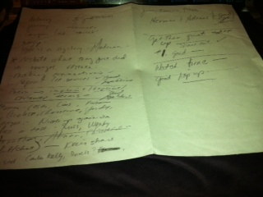
These are notes from my host teacher as she observed a lesson with one of the classes I taught that day. After every class we would debrief and reflect on how the lesson went, how the lesson may change class by class and what can be done to make it better.

